GRADE 7 ACCELERATED · UNIT 1 · LESSON 5
Solving Problems with Equations
Additional Practice 7A.01.05 ANSWER KEY

For questions 1 through 3, solve using your preferred method, then check your solution by substitution.
1. 4(0.5p + 1.5) = 12
2p + 6 = 12
2p = 6
p = 3
Check: 4(0.5(3) + 1.5) = 4(1.5 + 1.5) = 4(3) = 12 ✓
Dividing both sides by 4 first works just as well: 0.5p + 1.5 = 3.

 | 2. |  | = |  | ( z − 8 )

(5/2) × 4 = (1/4)(z − 8) × 4
10 = z − 8
18 = z
Check: (1/4)(18 − 8) = (1/4)(10) = 5/2 ✓
Multiplying both sides by 4 clears the fraction in one step.

 | 3. | 18 = |  | ( 36.4 − n )

18 ÷ (3/4) = 36.4 − n
24 = 36.4 − n
n = 12.4
Check: (3/4)(36.4 − 12.4) = (3/4)(24) = 18 ✓
18 × (4/3) = 24. Then subtract to isolate n; the negative in front of n is the step to watch.

For questions 4 and 5, rewrite the expression by applying the distributive property.
4. 5(2y − 7)
10y − 35
5 multiplies both terms: 5(2y) = 10y and 5(−7) = −35.

5. (m + 3.5)(−6)
−6m − 21
(−6)(m) = −6m and (−6)(3.5) = −21. Both terms get the negative.
Josephine paid $650 to rent a beachfront cabana. For each guest who used the cabana, a $19.40 resort fee was added to the bill. The final bill was $882.80.
6. What was the total amount spent on the cabana?
$882.80
7. Which cost depends on the number of guests?
The $19.40 resort fee, because it is charged once for each guest.
8. Which cost is the same no matter how many guests use the cabana?
The $650 cabana rental.
9. Write and solve an equation to find how many guests used the cabana. Use g for the number of guests.
650 + 19.40g = 882.80
19.40g = 232.80
g = 12
Check: 650 + 19.40(12) = 650 + 232.80 = 882.80 ✓
12 guests used the cabana.

Sade was asked to solve ⅔(b + 2.5) = 9.5. Her work is shown. Use it for question 10.
( b + 2.5 ) = 9.5
· b + · 2.5 = 9.5 ·
b +  = 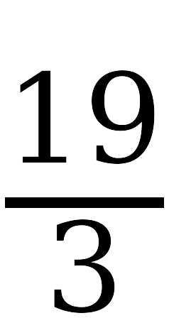
b = 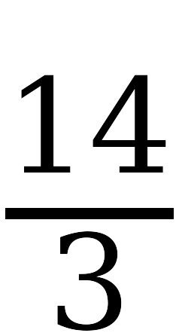
b = 7

10. Explain where Sade made her mistake, then find the correct solution.
Distributing is a way of rewriting one side of an equation, not an operation performed on both sides. Sade distributed ⅔ across the left side and then also multiplied the right side by ⅔. The right side should have stayed 9.5.
b + 2.5 = 9.5 ÷ (2/3) = 9.5 × (3/2) = 14.25
b = 11.75
Check: (2/3)(11.75 + 2.5) = (2/3)(14.25) = 9.5 ✓
Every line after her second one is arithmetically correct, which is what makes this error hard to spot. The mistake is in what she was allowed to do, not in what she computed.

